MTH 107
Test #2 (chapters 5-7)

Name ___________________________________________ Date ________________
- Find the probability that x falls in the shaded area.
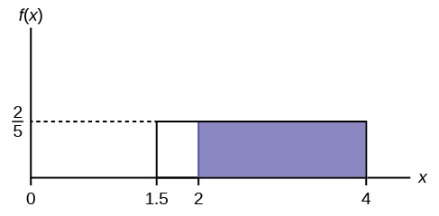
Solution
The probability will be the area between f(x)=2/5 for the shaded part 2<=x<=4 is the area of the rectangle:
- Pr(shaded) $=\frac{2}{5}*\left(4-2\right)=\frac{2}{5}*2=\frac{4}{5}$
$$=0.8$$

- The average amount of weight gained by a person over the winter months is uniformly distributed from 0 to 30lbs. Find the probability a person will gain between 10 and 15lbs during the winter months.

Solution
$$P\left(10<x<15\right)=base*height$$
$$\left(15-10\right)*\left(\frac{1}{30-0}\right)=5*\frac{1}{30}=\frac{1}{6}$$
$$≈0.167$$

- The amount of time it takes Kathy to make scrambled eggs in the morning is continuous and uniformly distributed between 2 minutes and 8 minutes. What is the probability that it takes Kathy between 3 and 4 minutes given that it takes less than 5 minutes for her to make scrambled eggs?

Solution
$$P\left(\frac{3≤x≤4}{x<4}\right)$$
$$=\frac{8-5}{(8-4)(8-3)}=\frac{3}{20}$$

- The random variable has a uniform distribution with values between 35 and 60. What is the mean and standard deviation of X? Round your answer to the nearest thousandth.

Solution
Mean
$$μ=\frac{1}{2}\left(a+b\right)$$
$$\frac{1}{2}\left(35+60\right)=47.5$$

Std.dev

$$σ=\sqrt{\frac{{\left(b-a\right)}^{2}}{12}}=\sqrt{\frac{{\left(60-35\right)}^{2}}{12}}$$
$$≈7.217$$

- Given the plot of normal distributions A and B below, which of the following statements are true? Select all correct answers.
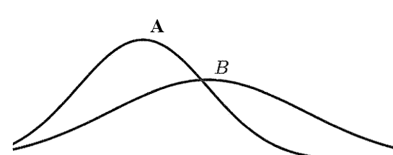

- A has a larger mean.
- B has a larger mean.
- A and B have equal means.
- A has a larger standard deviation.
- B has a larger standard deviation.
- A and B have equal standard deviations.

- The length of time it takes to find a parking space at 9 am follows a normal distribution with a mean of 5 minutes and a standard deviation of 2 minutes. Find the probability that it takes at least 8 minutes to find a parking space.
Solution
$$μ=5,σ=2$$
$$P\left(x≥8\right)=1-P(x<8)$$
$$Z=\frac{x-μ}{σ}=\frac{8-5}{2}=1.5$$
From std.normal tables, Z=1.05, has probability p= 0.933
$$1-P\left(x<8\right)=1-0.9332$$
= 0.0668

- Peter has collected data to find that the finishing times for cyclists in a race has a normal distribution. Based on the Empirical Rule, what is the probability that a randomly selected race participant had a finishing time of greater than 171 minutes if the mean is 156 minutes and the standard deviation is 15 minutes? Enter your answer as a percent rounded to 2 decimal places if necessary.

Solution
The no. of std. deviations from mean will be:
$$\frac{171-156}{15}=1 std. dev$$
$$Empirical rule : Approx. 68\% of the data lies between ± 1 SD$$
Thus: P(x>171) =$1-\left(0.68+\frac{1-0.68}{2}\right)$
$=0.16$

- Assume that the national average score on a standardized test is 1010, and the standard deviation is 200, where scores are normally distributed. What is the probability that a test taker scores less than 1600 on the test?

Solution
$$μ=1010,σ=200$$
$$P\left(x<1600\right)$$
$$Z=\frac{x-μ}{σ}=\frac{1600-1010}{200}=2.95$$
From std.normal tables, Z=2.95, has probability p= 0.9984
- $P\left(x<1600\right)≈0.9984$

- The percent of fat calories that Americans consume each day is normally distributed with a mean of 36 and a standard deviation of 10. Find the 77th percentile for the number of fat calories Americans consume.

Solution
From std normal tables, the z value given area of 0.77 will be $≈0.74$

Now, $Z=\frac{x-36}{10}=0.74$
- $x=\left(10\right)\left(0.74\right)+36=43.4$
That the 77th percentile will be= 43.4

- A professional basketball player made 37% of his shots in a season. If 80 attempts are randomly selected, what is the probability that at most 35 shots were made?
Solution
Using binomial probability distribution, p=037, n=80
P(x$≤35)=p(x=0,1,2,…35)$
=p(0)+p(1)+p(2)+ …+p(35)

$$≈0.965$$

- Suppose in a local Kindergarten through 12th grade (K - 12) school district, 53% of the population favor a charter school for grades K through 5. A simple random sample of 300 is surveyed. Using the normal distribution to approximate the binomial distribution, find the probability that at least 160 favor a charter school.
Solution

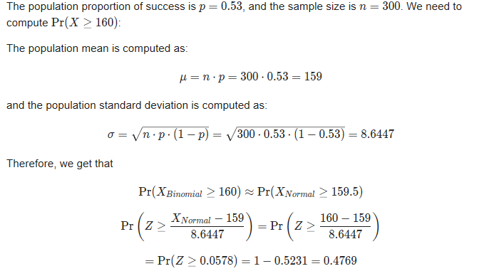
- $P\left(Z≥160\right)=0.4769$

- According to the latest financial reports from a sporting goods store, the mean sales per customer was $75 with a population standard deviation of $6. The store manager believes 39 randomly selected customers spent more per transaction. What is the probability that the sample mean of sales per customer is between $76 and $79?
Solution
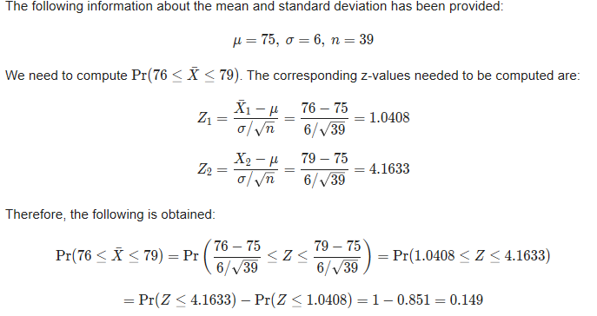
= 0.149
- An unknown distribution has a mean of 20 and a standard deviation of 3. A sample size of 30 is drawn randomly from the population. Find the mean and the standard deviation for the sum of the 30 values.
Solution
- (n)(μX)=the mean of ∑X
$$=\left(30\right)\left(20\right)=600$$

- (√n)(σX)=the standard deviation of ∑X
$$=\sqrt{30}(3)≈14.43$$

- An unknown distribution has a mean of 45 and a standard deviation of 8. A sample size of 50 is drawn randomly from the population. Find the probability that the sum of the 50 values is more than 2,400.

Solution
$$Z=\frac{2400-\left(50\right)\left(45\right)}{\left(\sqrt{50}\right)\left(8\right)}≈2.65$$
$$P\left(Z>2.65\right)=1-P\left(Z<2.65\right)$$
$$=1-0.9960$$
$$=0.004$$

